Table of Contents

Introduction: 1

Visit Date - name change: 1

Visit End – new data input field: 1

Visitors bulk upload Process: 2

## Introduction:

The new changes are specific to Pre-Registration apps only. No changes in the Registration app and Admin app. New Changes are mentioned in the below screenshot with red numbers with circles.

1. Visit date name change.
2. Visit End date (New column addition)
3. Bulk upload process.

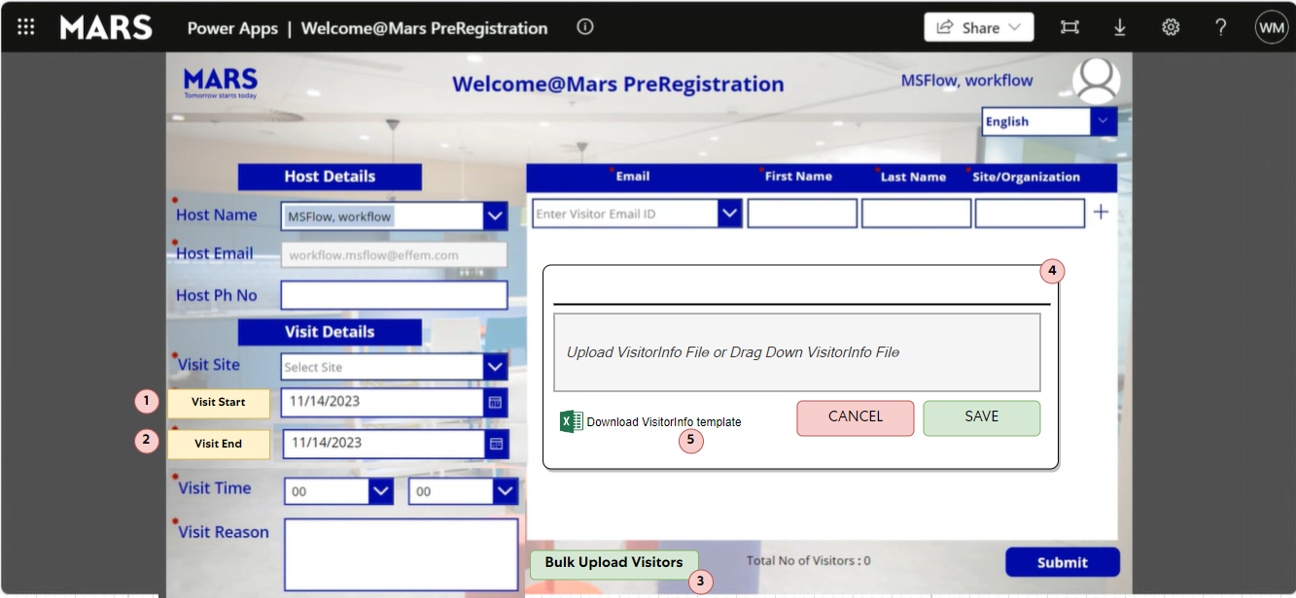

## Visit Date - name change:

As per the above screen (Point circled as 1), **Visit Date** is renamed as **Visit Start**. Here are there no functionality changes related to Visit Date.

## Visit End – new data input field:

As per the above screen (Point circled as 2), new input data field is added to collect the **Visit End** date. When user is adding end date, system will create one entry per day for the duration of visit.

For example:

1 - If host is selecting **Visit Start** date and **Visit End** date as April 4th then system will create single entry in the **Visitor Registration Details** list.

2 – If host is selecting **Visit Start** date as April 4th and **Visit End** date as April 5th, System will create two entries in the Visitor Registration Details list. (One entry for April 4th and One entry for April 5th).

## Visitors bulk upload Process:

For updating multiple Visitors in the Pre-Registration app, we have added Bulk Upload functionality.

Step 1 - As per the below screen, there will be a “Bulk Upload Visitor” button available in the Pre-registration app.

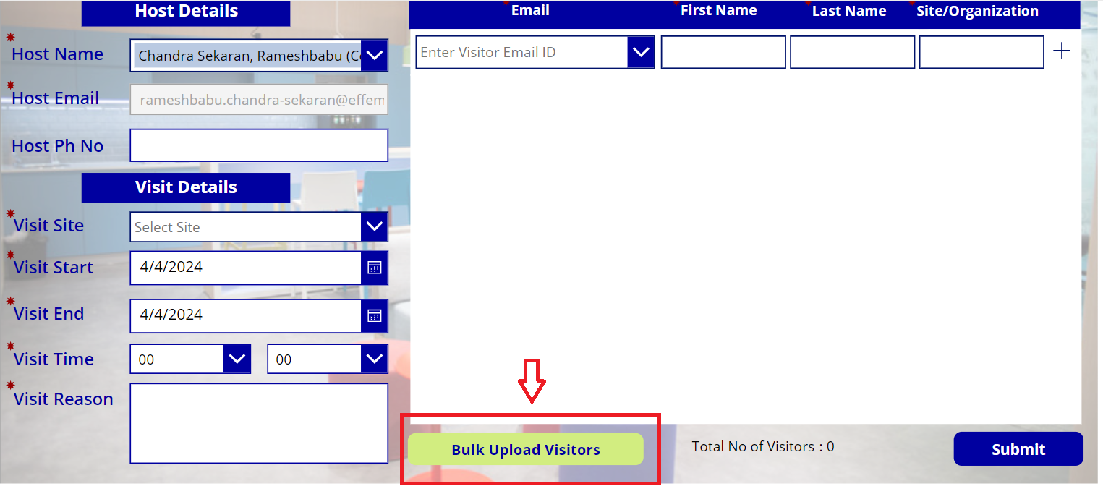

Step 2 – Once **Bulk Upload Visitors** button is clicked below pop-up screen will open. Please click on the “Download Visitor Info Template” and File will be downloaded in your local.

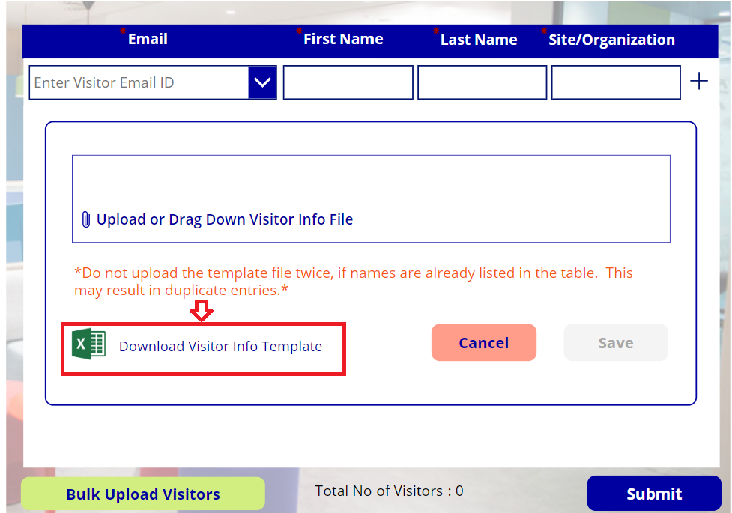

Step 3 – Open the file and add the Visitor detail as shown below.

Step 4 - Save the file and upload the file back to the system. Click “Save” button and wait for few seconds.

*Do not upload the template file twice, if names are already listed in the table. This may result in duplicate entries. *

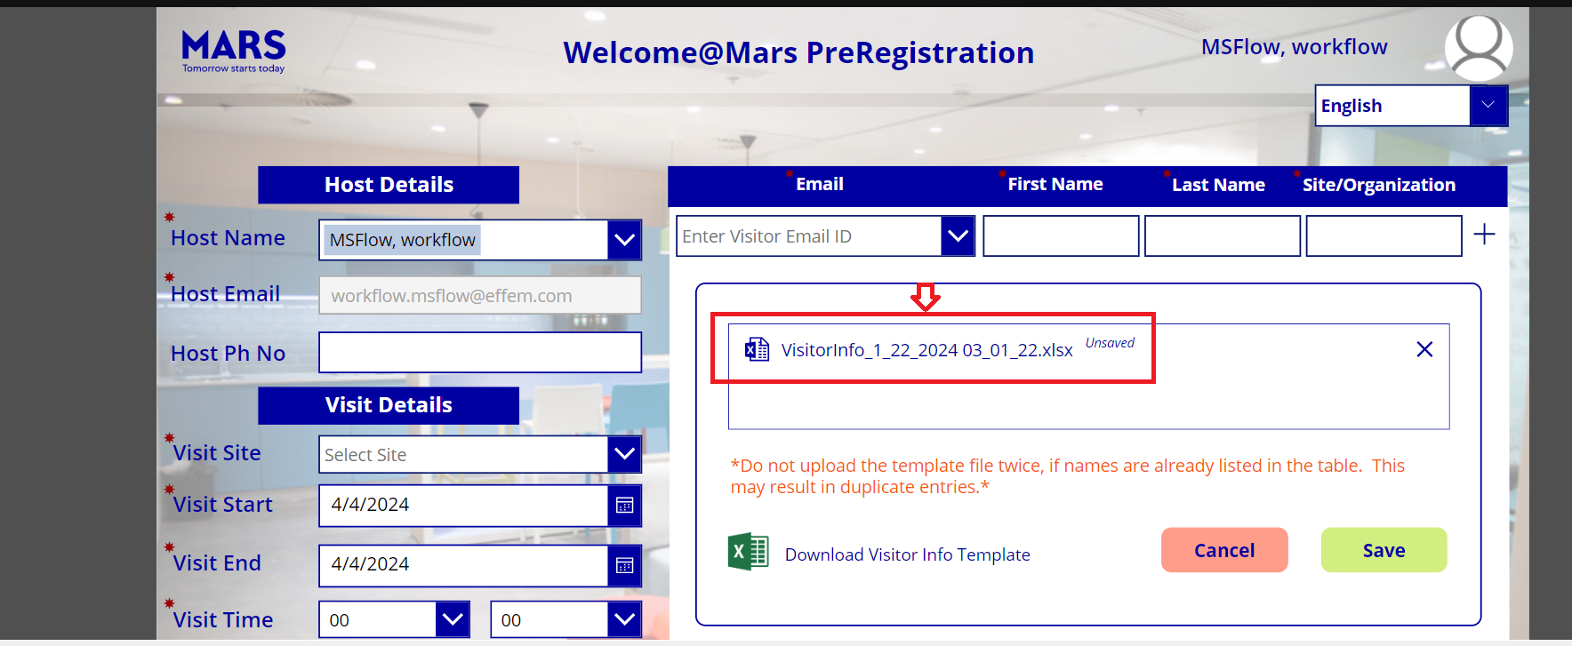

Step 5 – Once file uploaded successfully user will see below screen with added visitors.

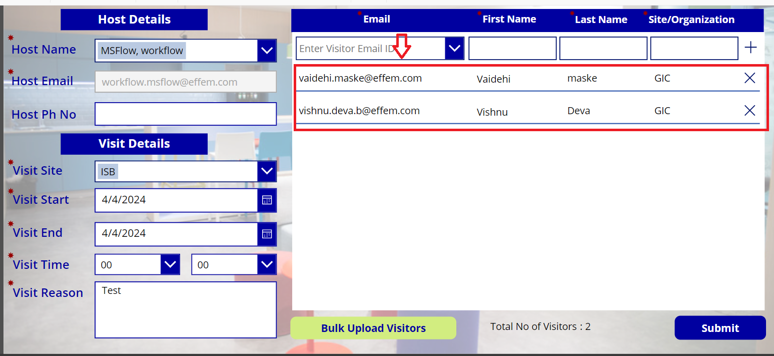

Step 6 – Once verified the visitors details Click “Submit” button.